PREDICTING PERSONAL LOAN APPROVAL USING MACHINE LEARNING

Project Based Experimental Learning program

**TEAM LEADER:**

**A. HASMA SAIDALI FATHIMA**

**TEAM MEMBERS:**

**1. T. SIVARANJANI**

**2. V. PRIYADHARSHINI**

**3. M. MONISHA**

**4. K. MAHALAKSHMI**

**MENTOR AND FACULTY,**

**S. SENTHAMILSELVAN**

**PREDICTING PERSONAL LOAN APPROVAL USING MACHINE LEARNING**

**INTRODUCTION**

OVERVIEW

Loans are the major requirement of the modern world. By this only, Banks get a major part of the total profit. It is beneficial for students to manage their education and living expenses, and for people to buy any kind of luxury like houses, cars, etc.

But when it comes to deciding whether the applicant’s profile is relevant to be granted with loan or not. Banks have to look after many aspects.

So, here we will be using Machine Learning with python to ease their work and predict whether the candidate’s profile is relevant or not using key features like Marital Status, Education, Applicant Income, Credit History, etc. Banks are making major part of profits through loans. Though lot of people are applying for loans. It’s hard to select the genuine applicant, who will repay the loan. The company/bank wants to automate the eligibility loan process based on details of customers provided while completing the application form. The details include Gender, Marital Status, Education, Number of Dependents, Income, Loan Amount, Credit History and other. This project has taken the previous customers data of various banks to whom on a set of rules loan were approved.

method to get approximate results. Our main of this project is to predict the loan safety.

**PURPOSE**

Loan prediction is very helpful for bank employees as well as for the aspirants. The main motive of the paper is to provide quick, fast and a very easy way to choose the eligible applicants. Dream housing Finance Company deals in various types of loans.

They have presence across all cities, towns and village areas. Applicants are first done by customers for loan after that company/bank validates the customer eligibility for getting the loan. They have presence across all cities, towns and village areas. Applications are first done by customers for loan after that company/bank validates the customer eligibility for getting as well as for the aspirants. The main motive of the paper is to provide quick, fast and a very easy way to choose the eligible applicants. Dream housing Finance Company deals in various types of loans.

They have presence across all cities, towns and village areas. Applicants are first done by customers for loan after that company/bank validates the customer eligibility for getting the loan. They have presence across all cities, towns and village areas. Applications are first done by customers for loan after that company/bank validates the customer eligibility for getting the loan.

**PROBLEM DEFINITION AND DESIGN THINKING**

**EMPATHY MAP**

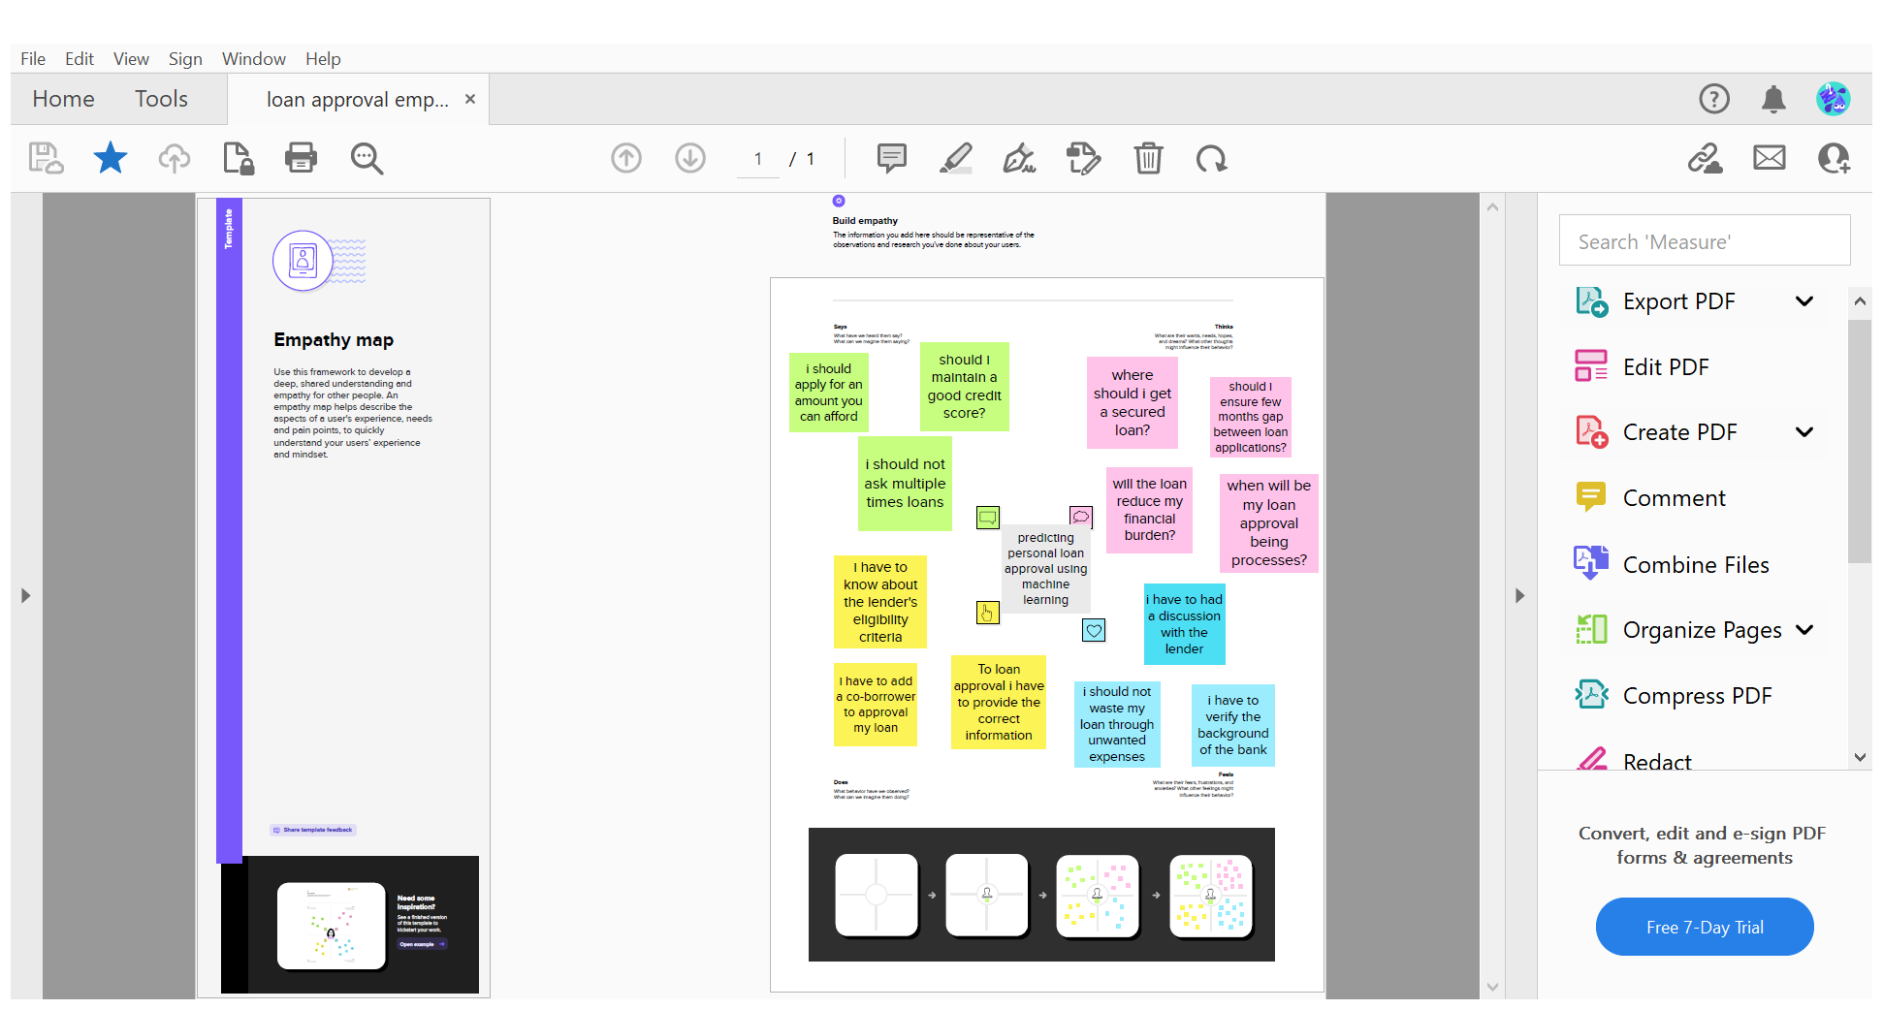

**BRAINSTORM AND IDEA PRIORITIZATION**

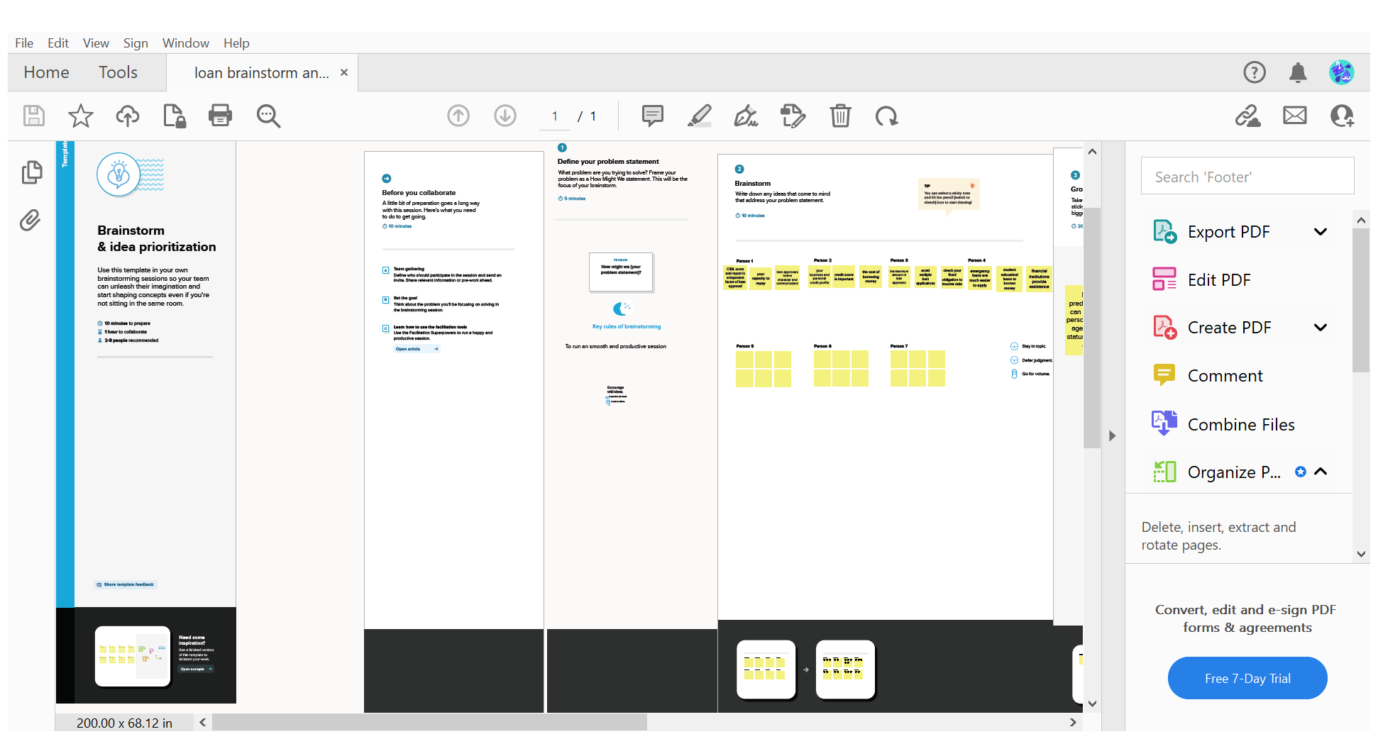

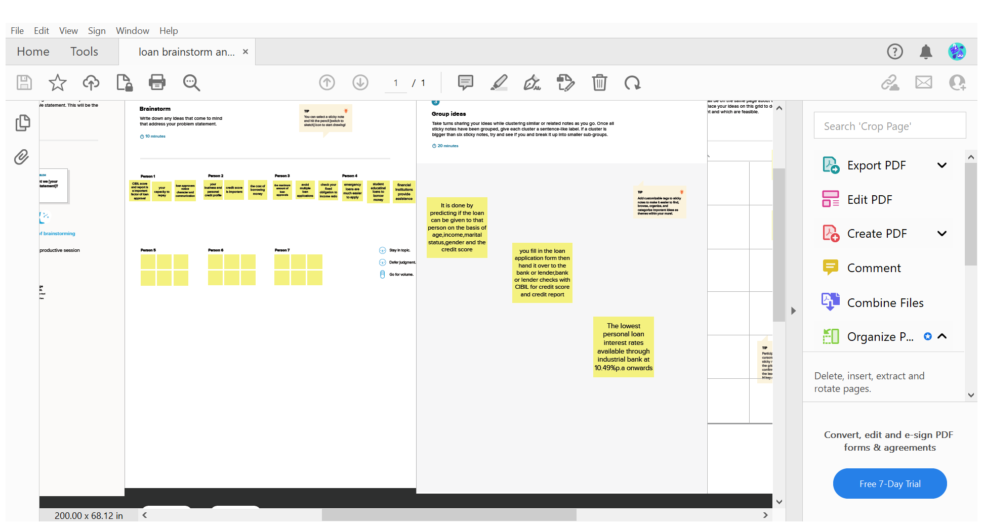

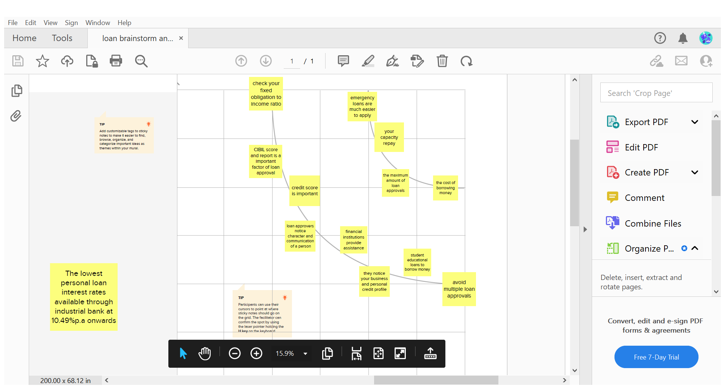

**ADVANTAGES AND DISADVANTAGES**

**ADVANTAGES**

**The project personal loan requires making regular, monthly payments toward the outstanding balance. Lenders typically report your payment record is taking out a to the three major credits—Equifax, Experian and TransUnion.**

**If you consistently make on-time payments, this can help increase your credit score.**

**This also means you can damage your score if you make late payments or default, making it harder to access credit in the future.**

**DISADVANTAGES**

**This project has the biggest disadvantage to personal loans is that you have to make a long-term financial commitment. While this could be fine if you have a stable income and predict you will still be earning the same amount or more in a number of years, this could be more difficult for those with fluctuating incomes, such as a freelancer or someone who is self-employed.**

**Another disadvantage is that getting a personal loan with a low interest rate is all based on your credit score. This means that if you have a poor or low credit score then you might not be eligible to get the best loan products available. If you have had issues with borrowing in the past or have ever missed a payment on a previous consumer credit product, it may be more difficult for you to get the loan that you want.**

**APPLICATIONS**

**This project While doing the process manually, lot of misconception may happen to select the genuine applicant. Therefore, we are developing loan prediction system using machine learning, so the system automatically selects the eligible candidates. This is helpful to both bank staff and applicant.**

**RESULT**

**HOMEPAGE**

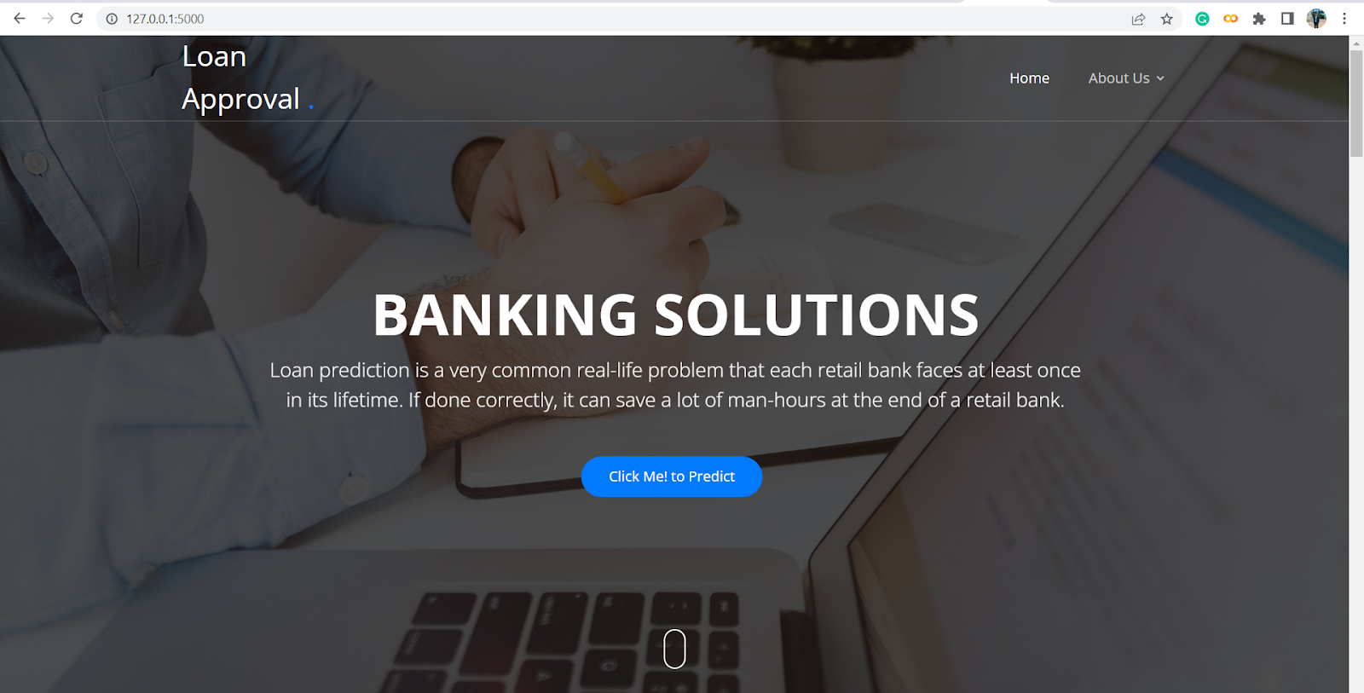

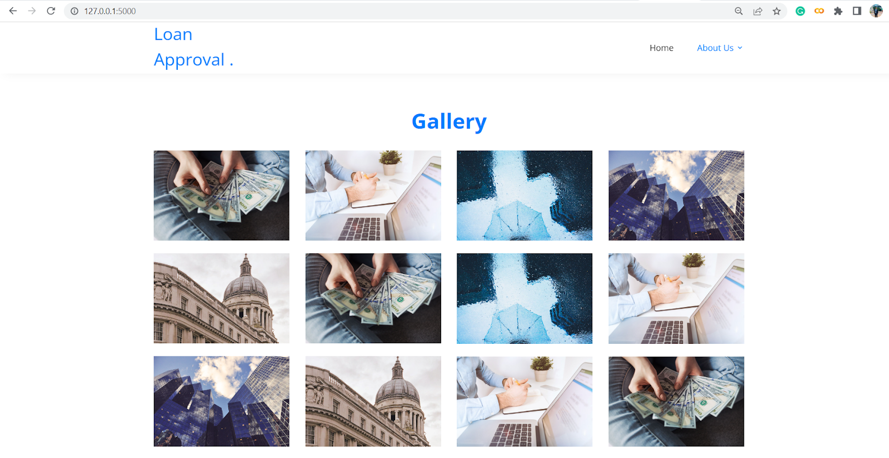

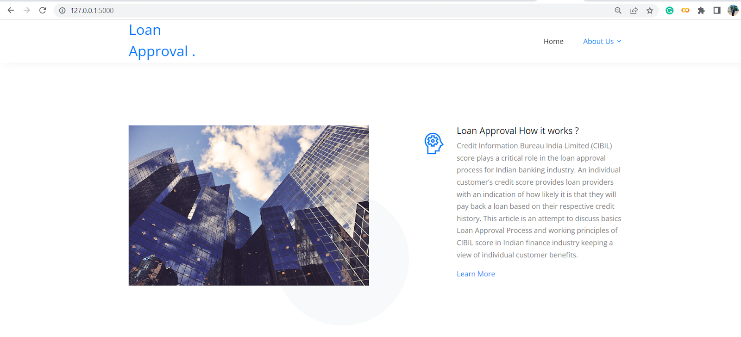

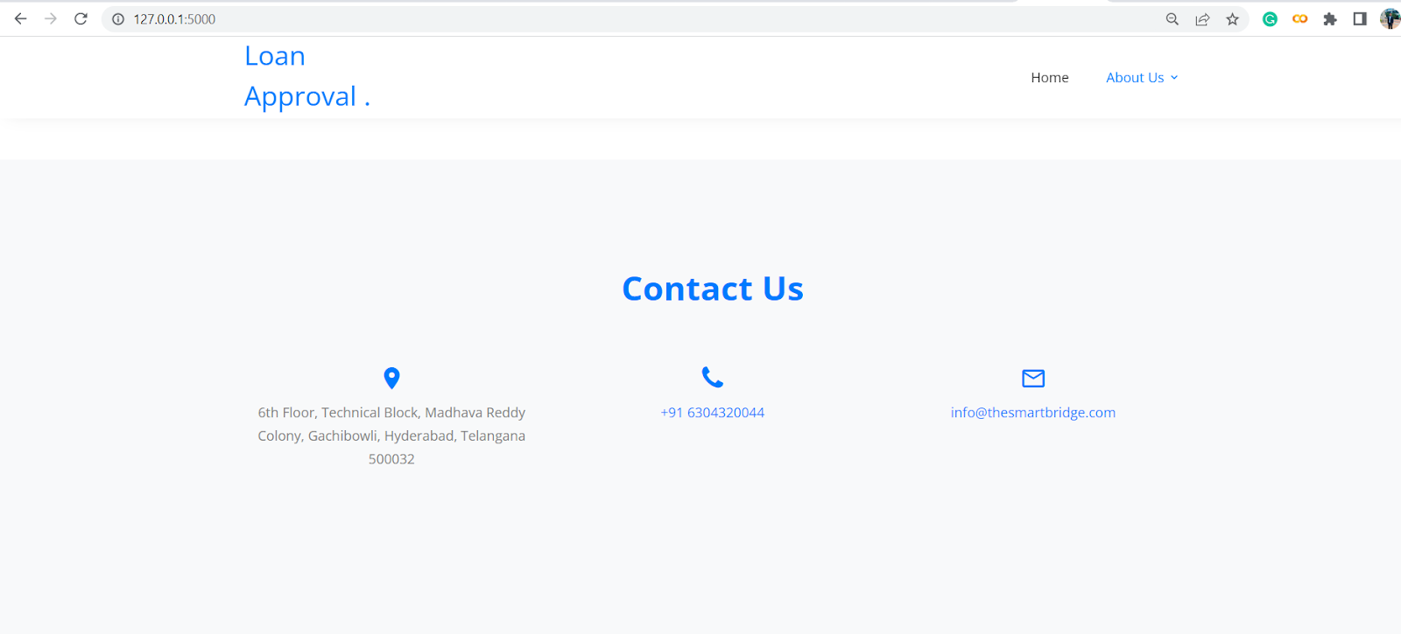

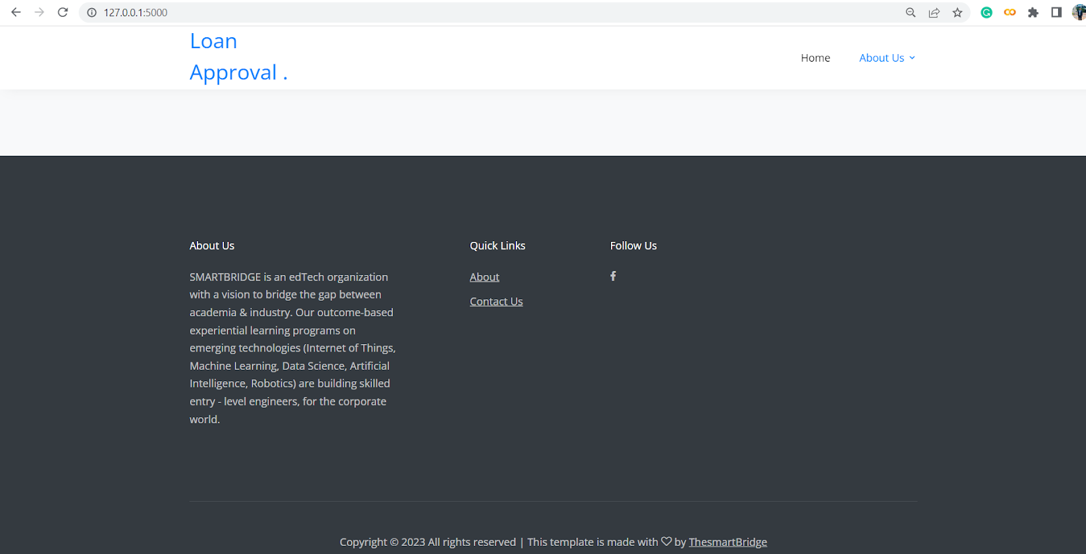

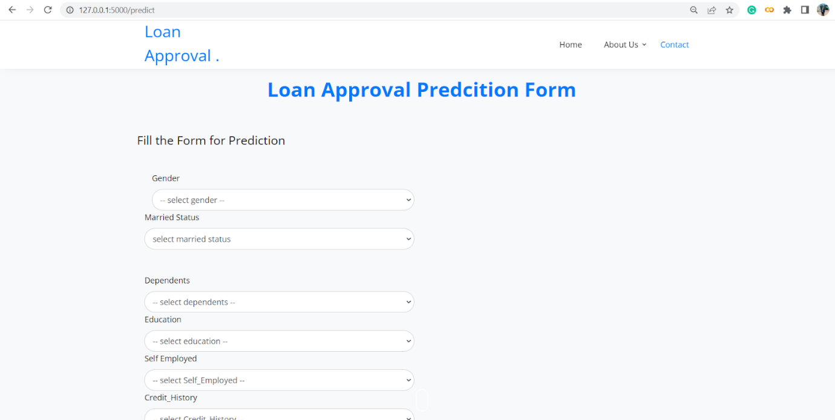

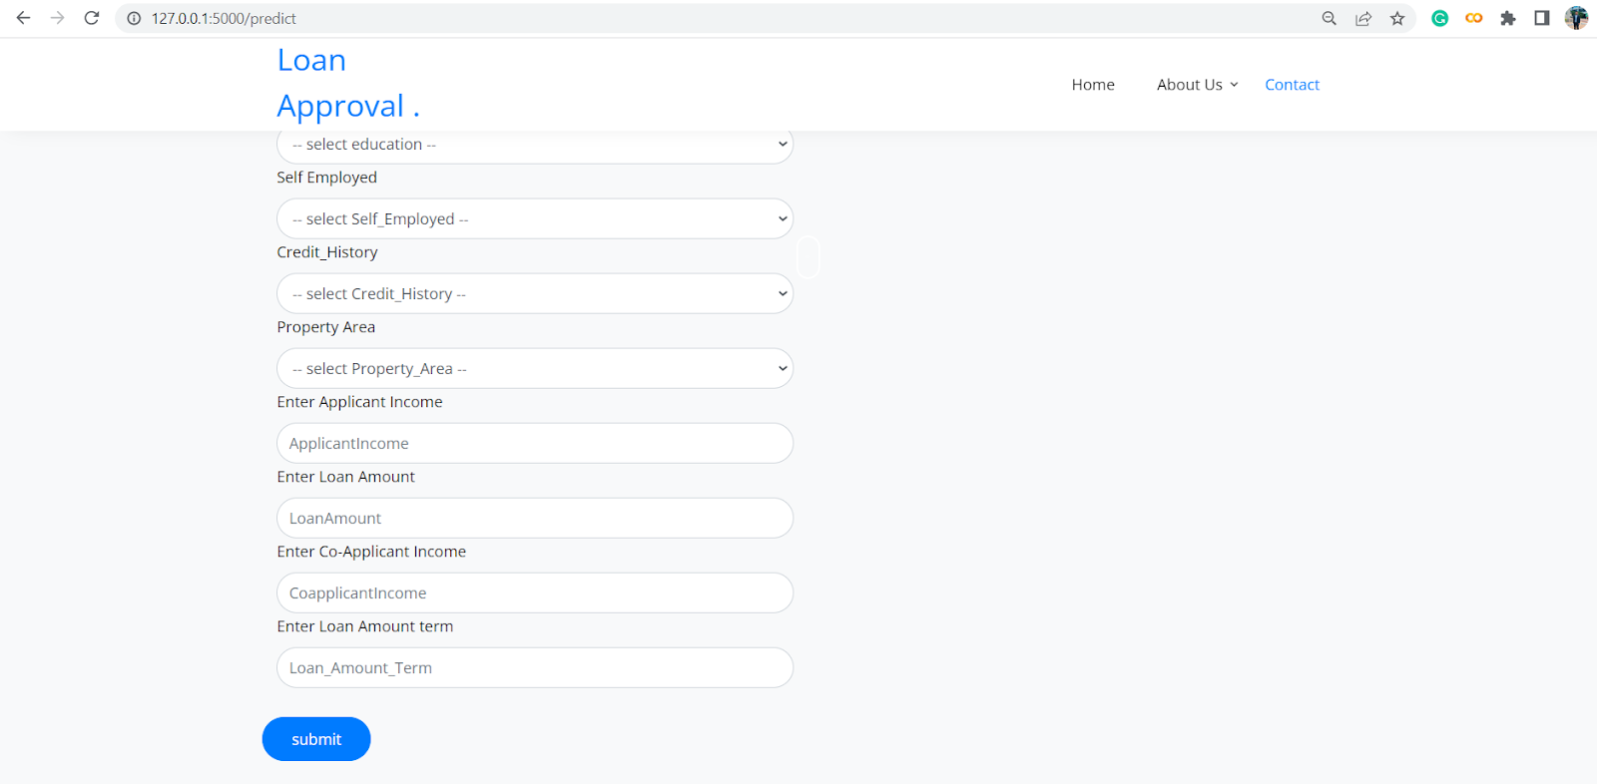

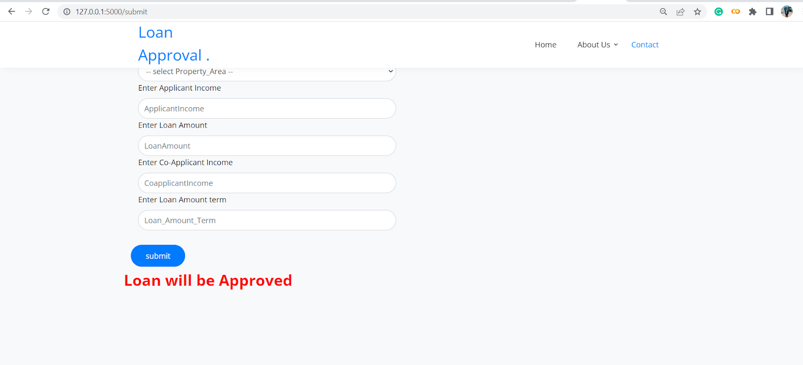

**CONCLUSION:**

**This project helped us to learn about the complicated system of the loan prediction system and the best model that can work with this particular project.**

**It works correctly and fulfils all requirements of bankers. This system properly and accurately calculates the result. It predicts the loan is approve or reject to loan applicant or customer very accurately.**

**FUTURE SCOPE**

**This project has to predict loan eligibility using machine learning.**

**And has many future scopes of Exploratory data Analysis, data visualizations, machine learning model decision, predict the model. It has to identify the customer segments that are eligible for loan amounts so that they can specifically target their customers.**

**APPENDIX**

**FLASK APP**

**app.py:**

**from flask import Flask, render template, request**

**import numpy as np**

**import pickle**

**app = Flask(__name__)**

**model = pickle.load**

**(open(r'rdf.pkl', 'rb'))**

**scale = pickle.load(open)(r'scale1.pkl','rb')**

**@app.route('/') # rendering the html template**

**def home():**

**return render_template('home.html')**

**@app.route('/submit',methods=["POST","GET"])# route to show the predictions in a web UI**

**def submit():**

**#  reading the inputs given by the user**

**input_feature=[int(x) for x in request.form.value() ]**

**#input_feature = np.transpose(input_feature)**

**input_feature=[np.array(input_featue)]**

**print(input_feature)**

**names = ['GENDER', 'MARRIED', 'Dependents', 'Education', 'Self_Employed', 'ApplicantIncome', 'CoapplicantIncome', 'Loan_Amount_Term', 'Credit_History', 'Property_Area']**

**das.DataFrame(input_feature,columns=names)**

**print(data)**

**#data_scaled = scale.fit_transform(data)**

**#data = pandas.DataFrame(,columns=names)**

**#predictions using the loaded model file**

**prediction=model.predict(data)**

**print(predictions)**

**prediction = int(prediction)**

**print(type(prediction))**

**if (prediction ==0);**

**return render_template("output.html",result = "Loan will Not be Approved")**

**else:**

**return render_template("output.html",result = "Loan will be Approved")**

**# showing the prediction results in a UI**

**if__name__=="__main":**

**#app.run(host='0.0.0.0', port=8000,debug=True)**

**port=int(os.environ.get('PORT,5000'))**

**app.run(debug=False)**

**hhome.html:**

**<!DOCTYPE html>**

**<head>**

**<title>about</title>**

**</head>**

**<body>**

**<style> body**

**{**

**Background image:url**

**(https://i.ibb.co/Z8Hs8xs/image11.png);**

**background-repeat: no-repeat;**

**background-color: none;**

**background-position: center;**

**background-attachment: fixed;**

**background-size: 1300px;        }**

**</style>**

**</body>**

**</html>**

**y_predict.html:**

**<!DOCTYPE html>**

**<head>**

**<title>about</title>**

**</head>**

**<body>**

**<style> body**

**{**

**background-image:url**

**(https://i.ibb.co/WvFybK9/image1-2.png);**

**background-repeat: no-repeat;**

**background-color: none;**

**background-position:**

**center;**

**background-attachment: fixed;**

**background-size: 1300 px;**

**}**

**</style>**

**</body>**

**</html>**